**SpringBoot MVC**

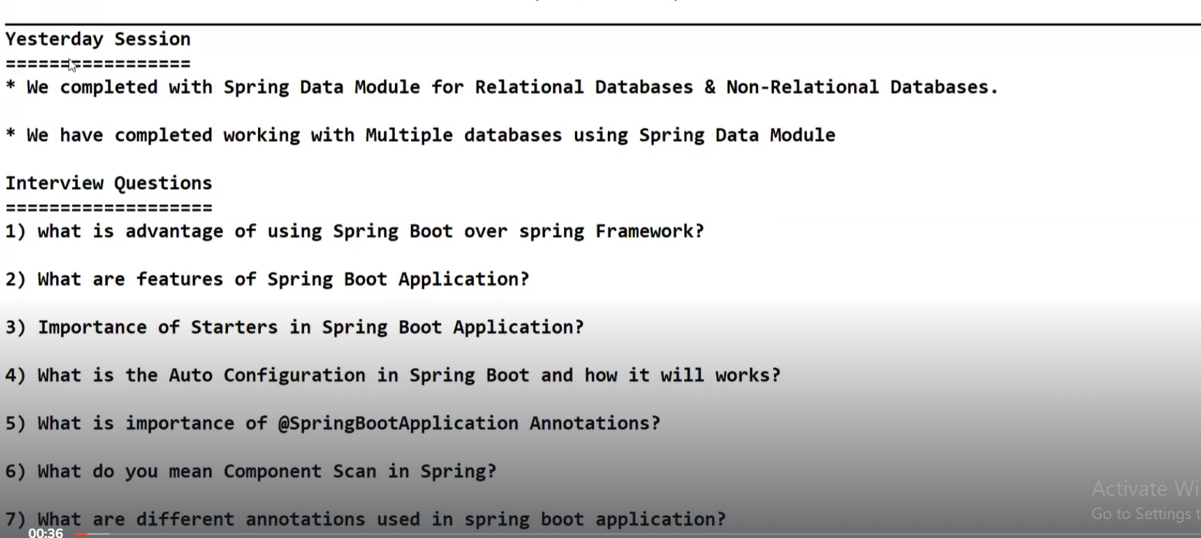

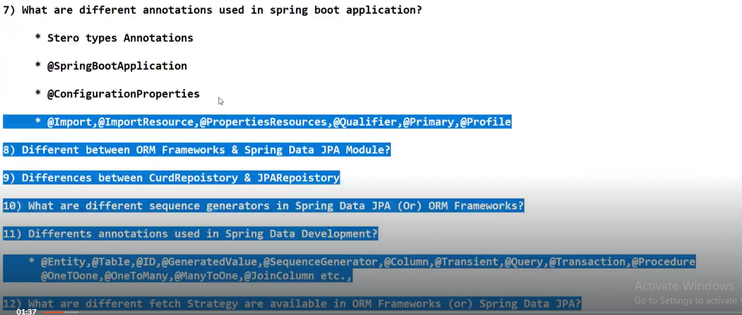

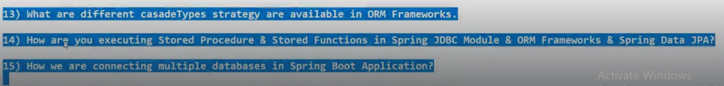

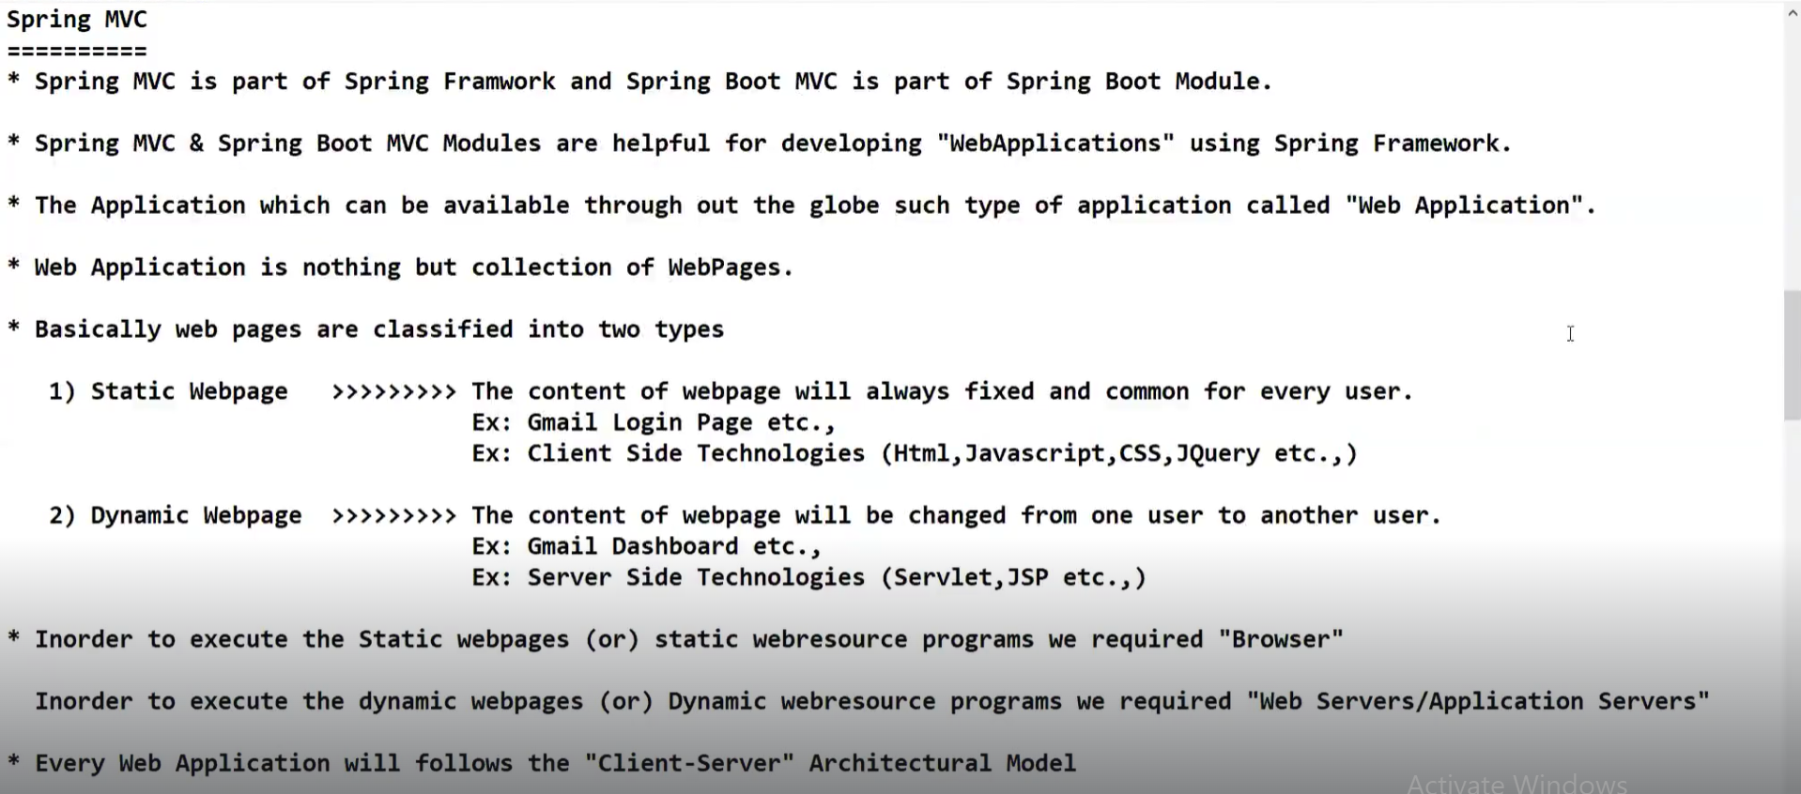

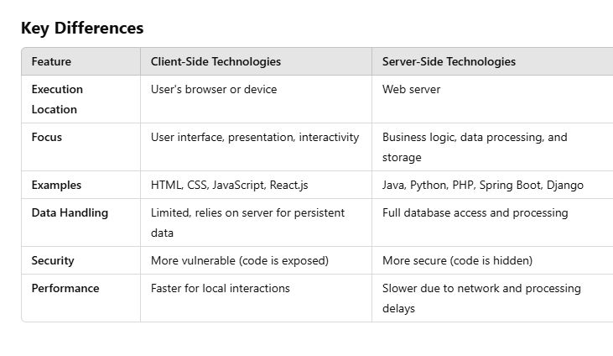

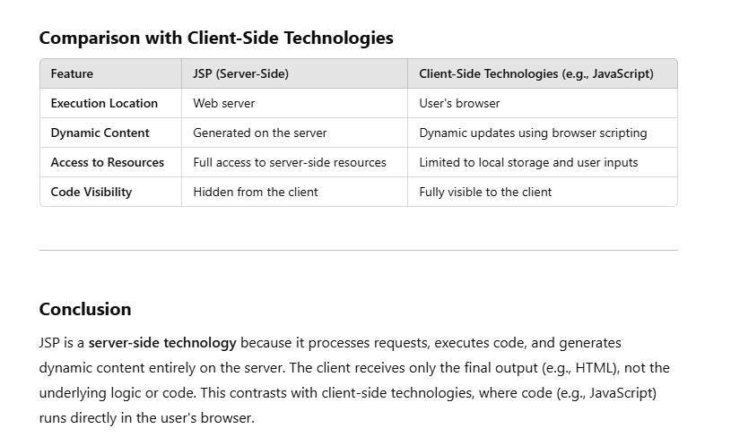

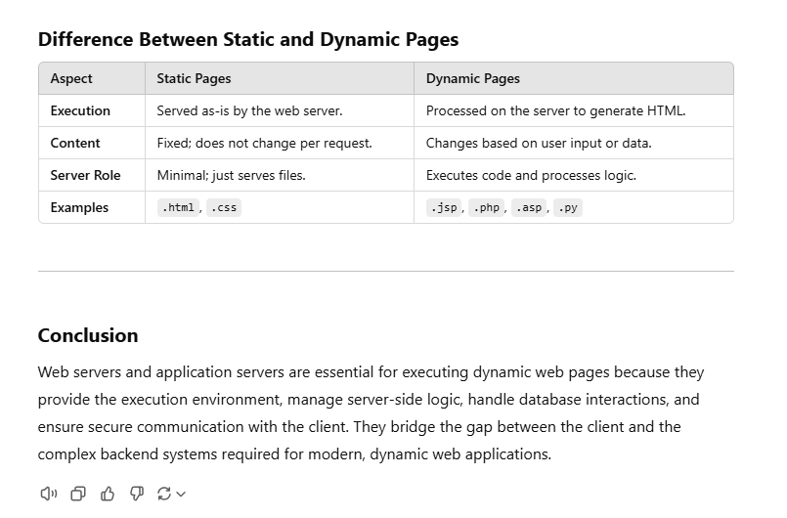

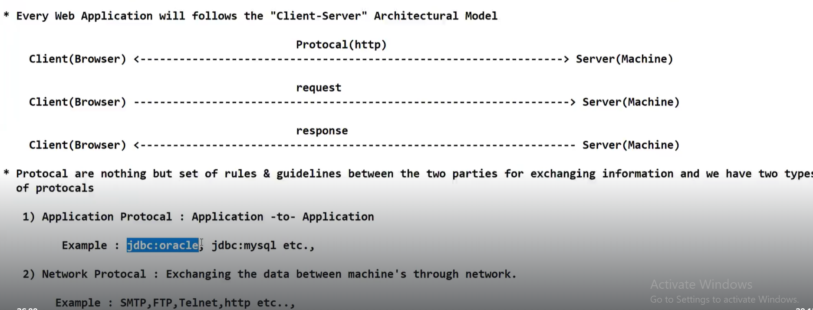

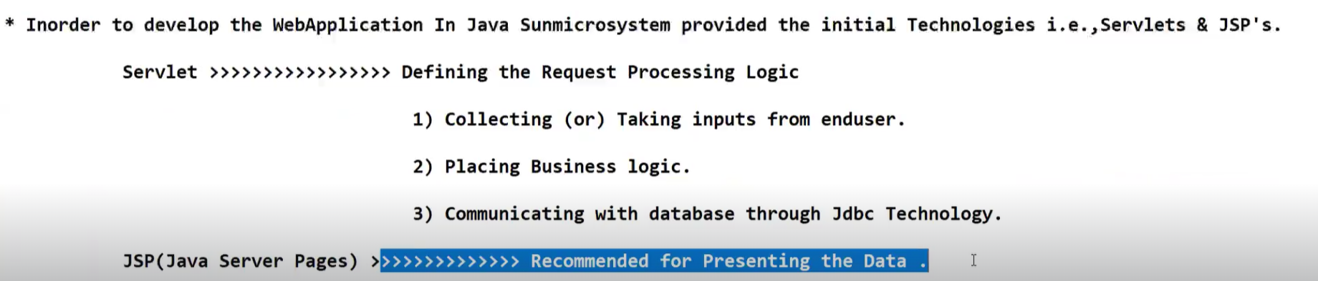

From Tomcat 10 onwards, Jakarta comes into picture.

Till Tomcat 9 version, when you are working with Web applications,all the Servlet related classes are organised in Javax.servlet package.

Whereas when you are developing web applications and deploying into Tomcat 10 server, all the Servlet related classes are packaged into Jakarta.servlet package.

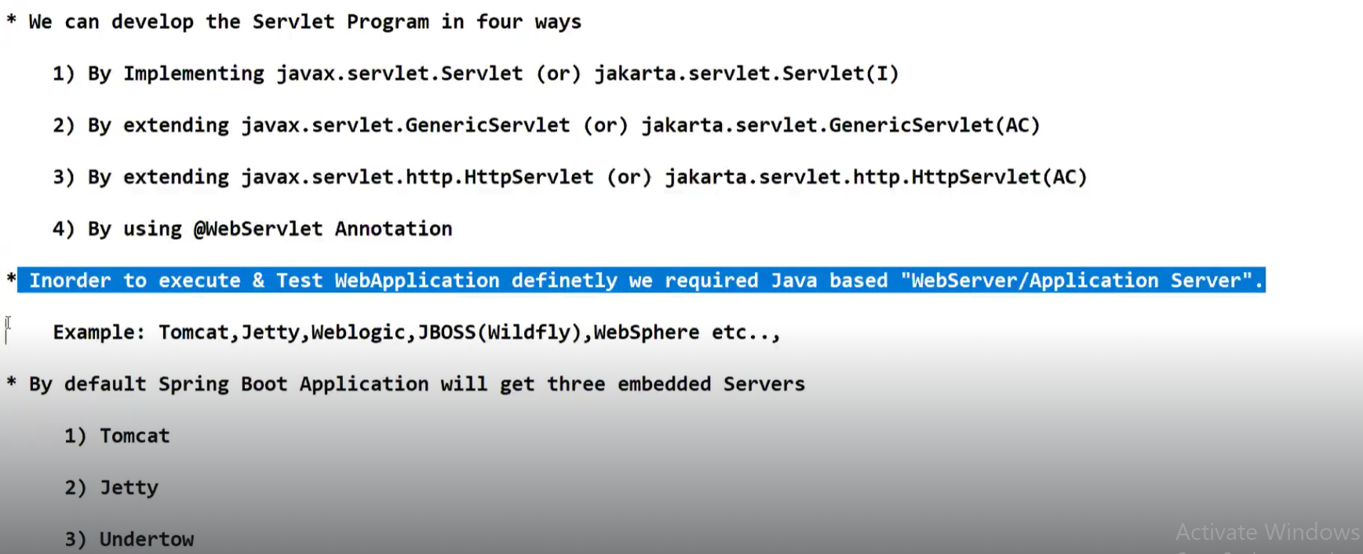

Earlier when you want to develop web applications using Servlets and JSPs you need to instal atleast one Java based web server or application server in your local machine itself.But when you are developing web applications using Spring Boot MVC,by default you will be getting three embedded servers.You no need to install the servers explicitly in your local machine.Servers which comes along with your spring boot application are called Embedded servers.

**Internationalization(I18N): Developing a web application to support multiple languages**

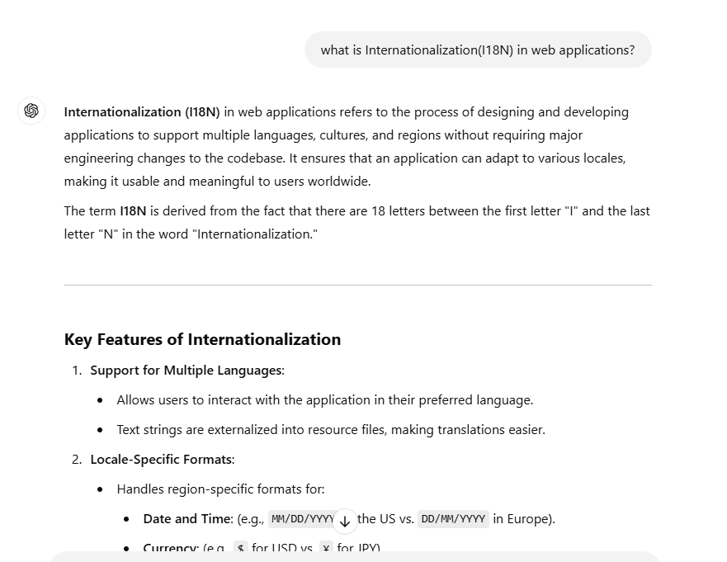

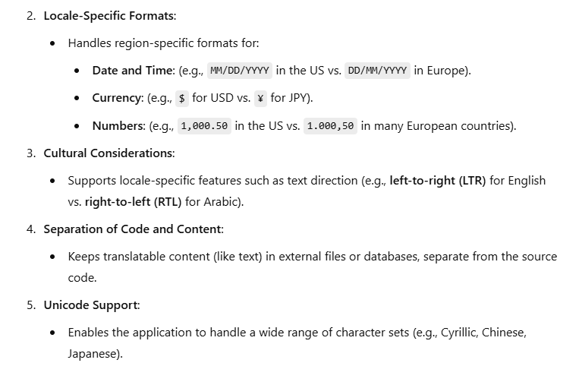

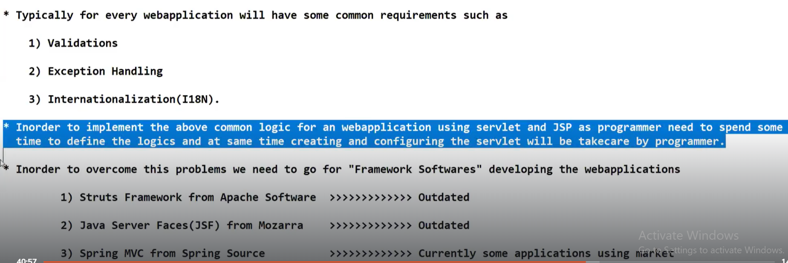

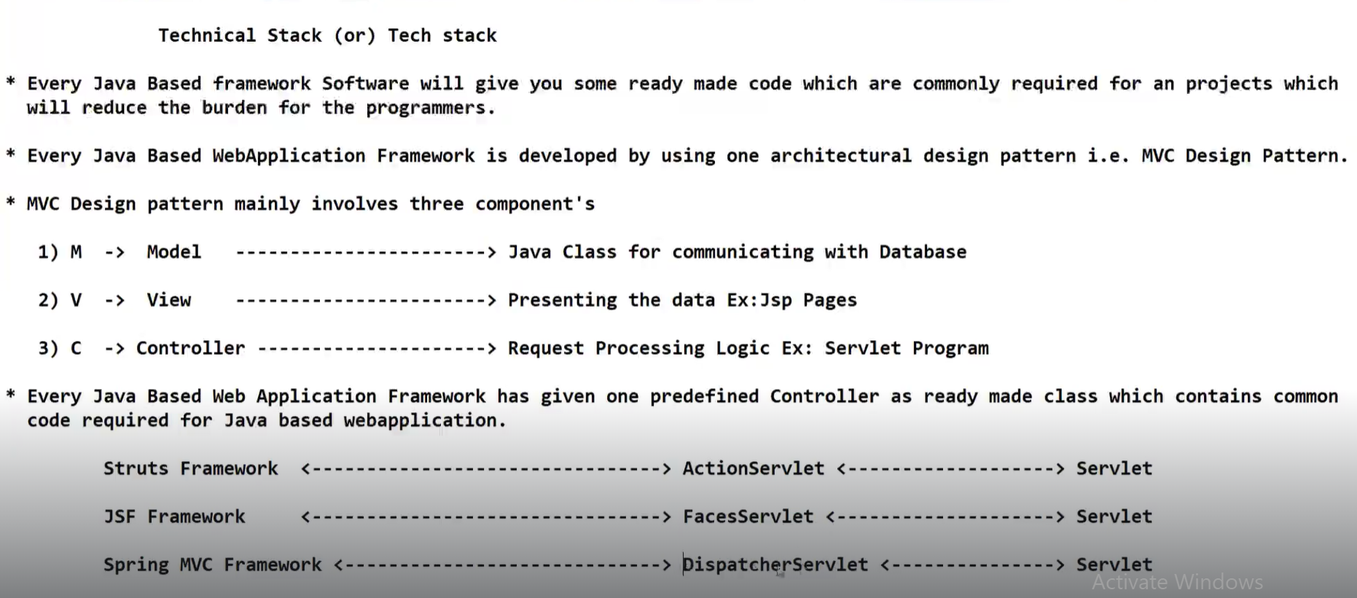

When we are working with JSP and Servlets technology, programmer needs to take care of Model,View, Controller.

Where as when we are working with Frameworks , Controller is ready made and given to us.We just need to configure the given controller as per our requirement and that makes our job easy.

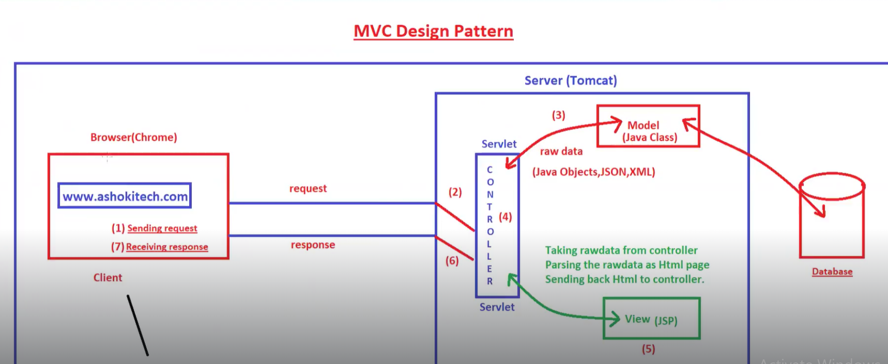

As per MVC design pattern, you can have n number of Models, n number of Views but you can have only one controller.

Every request should pass through that controller.

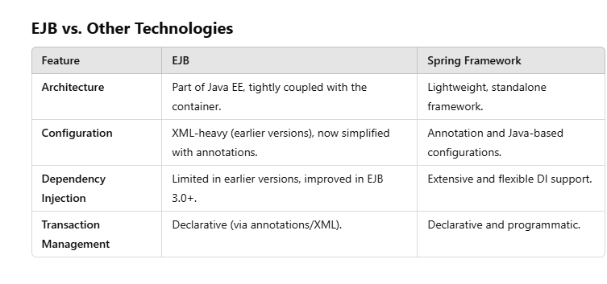

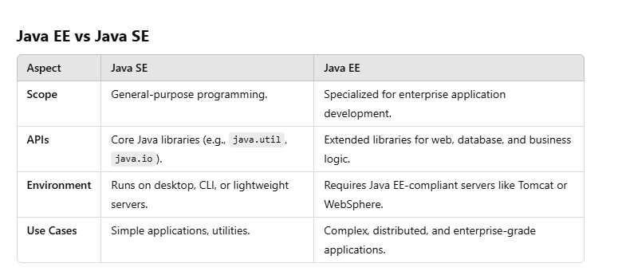

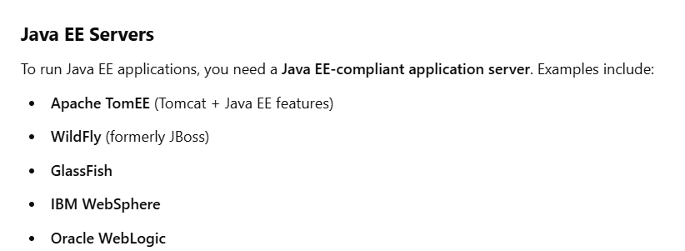

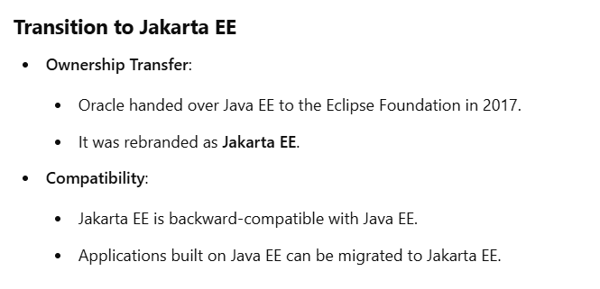

**SESSION-64**

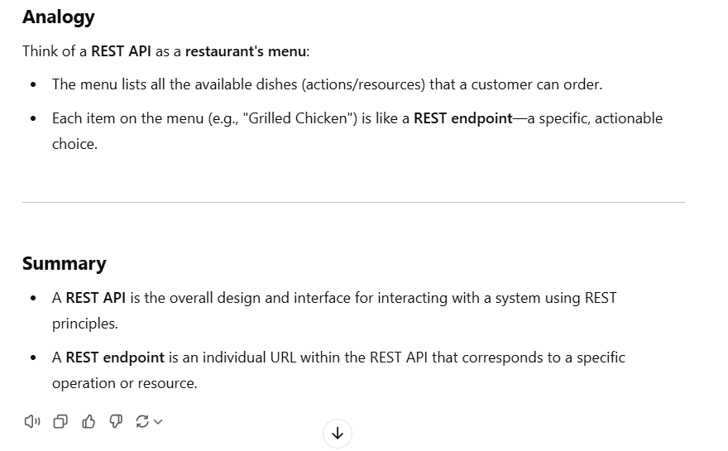

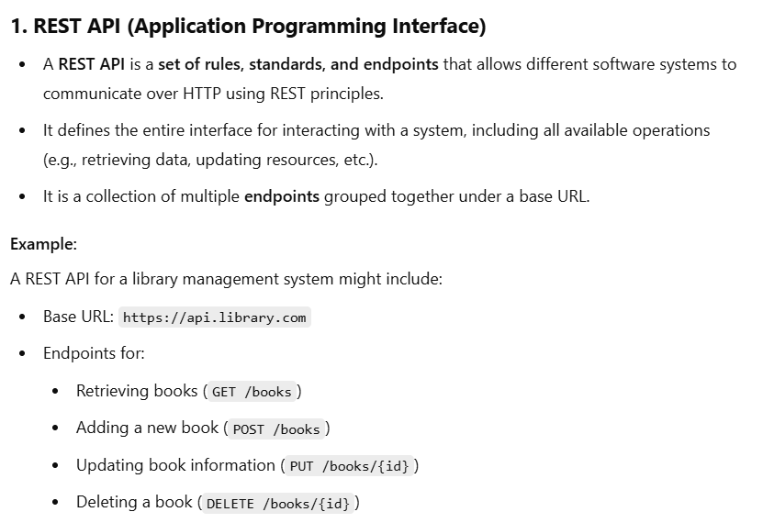

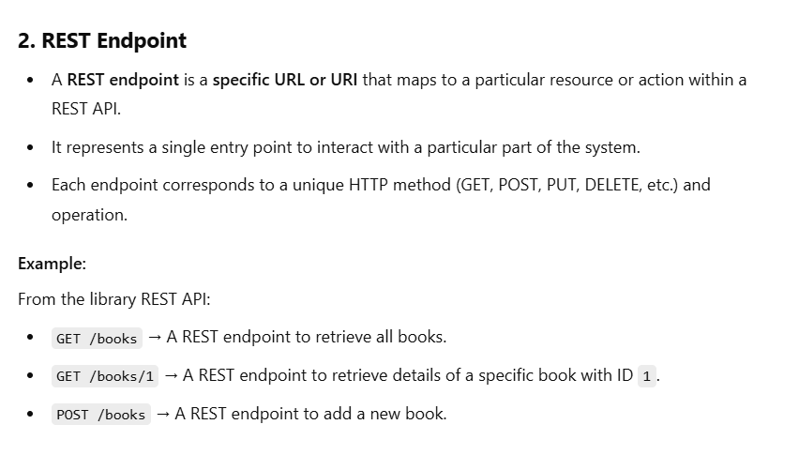

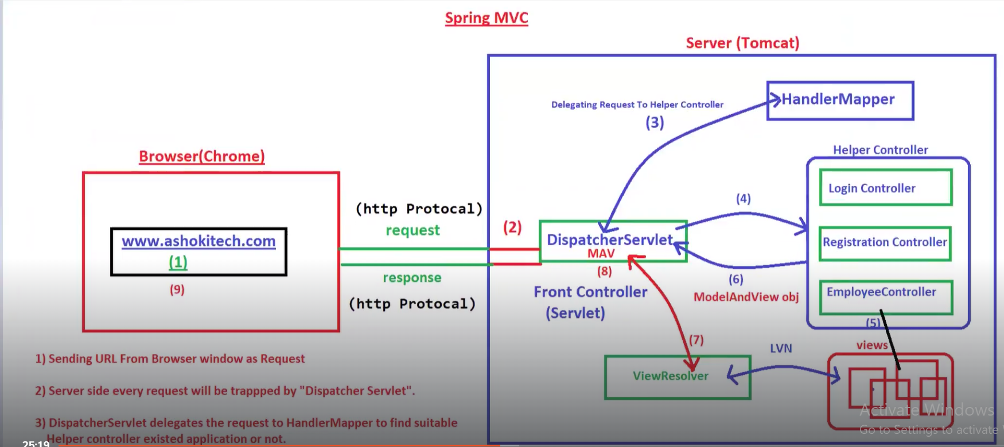

The components whichever are highlighted in Green color will be taken care by Programmer to be configured in application.

Those are Dispatcher servlet, ViewResolver, Login,Registration,Employee controllers

**In the diagram LVN means Logical View Name**

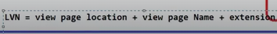

**Extension can be .jsp page or .html page**

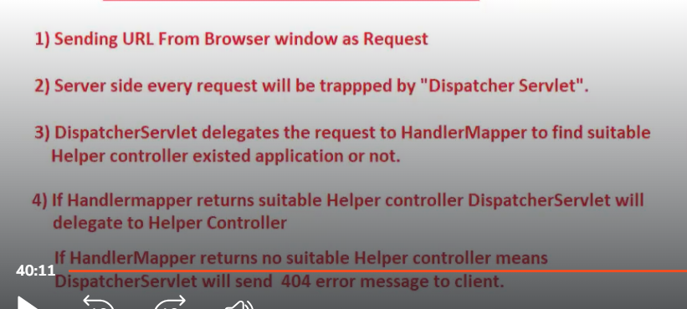

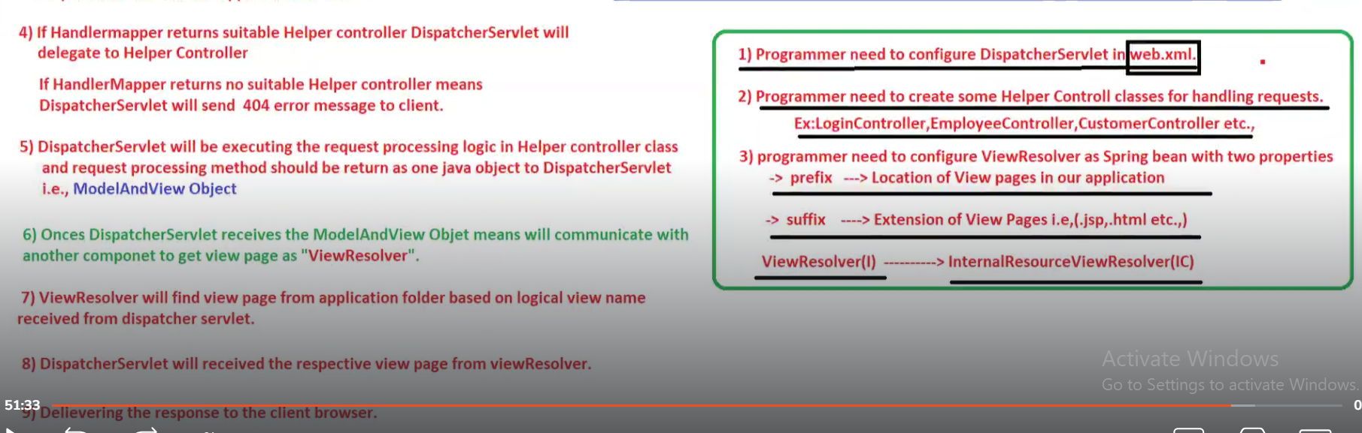

-->Dispatcher servlet is a Servlet program from Spring MVC.

--> DispatcherServlet is one of the pre-defined controller in Spring MVC.DispatcherSevlet will check whether incoming request is valid request or not.

--->Dispatcher Servlet will commuincate with Handler mapper to identify which helper controller needs to be executed.We will be having multiple helper controllers in an application.

-->Helper Controller classes are nothing but Java classes having a set of methods.Each and every method is mapped with a URL pattern.

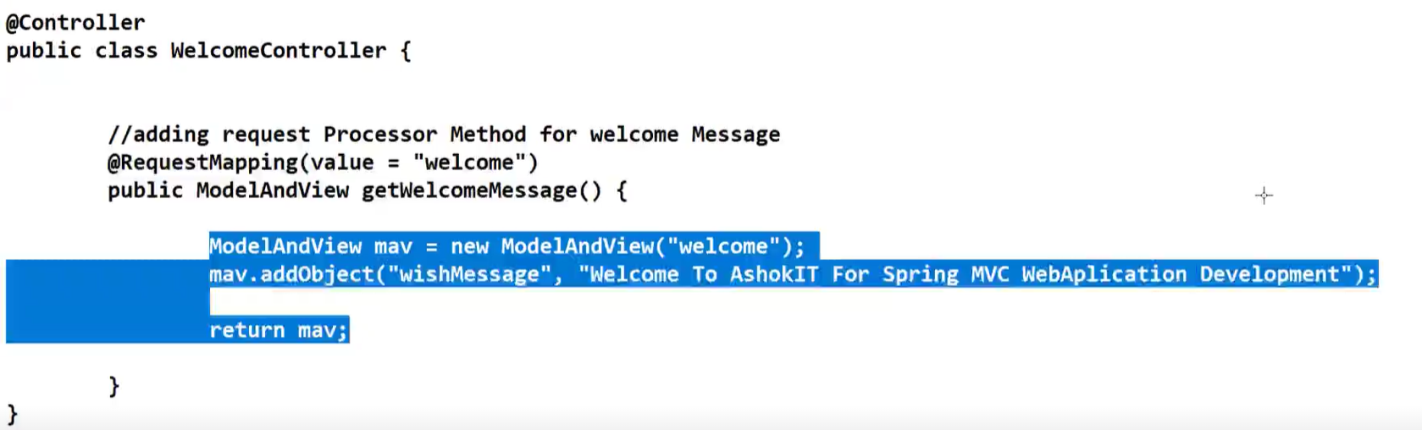

-->Whenever a method is mapped with a request, it should return MAV object.

**MAV means Model and View. --It contains model information and view information.**

**--->Once DispatcherServlet receives MAV object from helper controller, it will communicate with View Resolver.**

**--->View resolver is one of the predefined components in Spring MVC.It always helps us to pick the View pages from the directories.View pages means JSP pages.**

**---> View page will be returned back to Dispatcher Servlet by View Resolver.Then DispatcherServlet will delegate that View Page reponse to server and then server will delegate the response to client.**

**Web.xml file contains Servlet related information - what are different servlet programs available incour application ,what are different URLs available for each and every respective servlet, some kind of filters available in our web application**

**Purpose of filters in web application:To execute pre-processing logic and post-processing logic of request**

**Listeners: Event handling mechanicsm in web applications is achieved by using Listeners.**

**Spring MVC is coming from Spring framework.SpringBoot MVC is coming from SpringBoot framework**

**Spring Boot MVC is an extension of Spring MVC.**

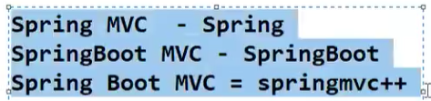

Session-65

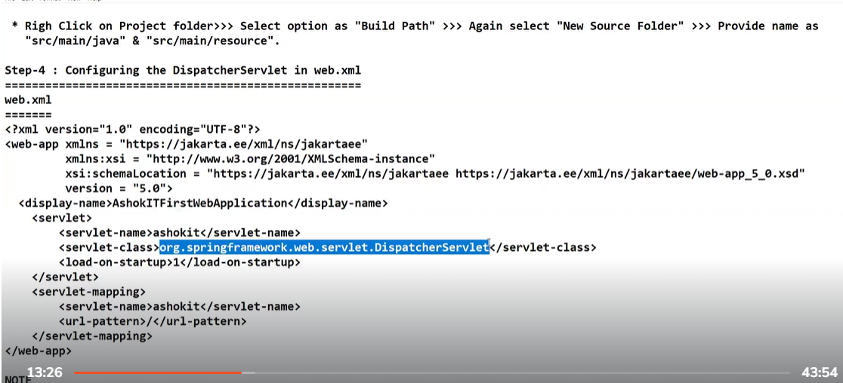

<load-on-startup> == when you give value load-on-startup with some positive value, that object will be created during server startup time itself

<Servlet-mapping> == which request will be handled by dispatcher servlet.In above screenshot, the request that ends with / will be handled by Dispatcher servlet

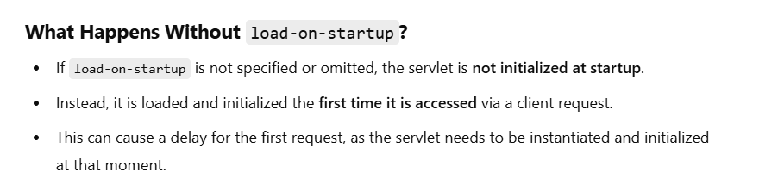

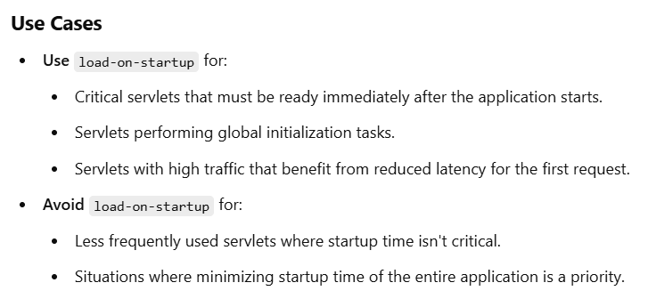

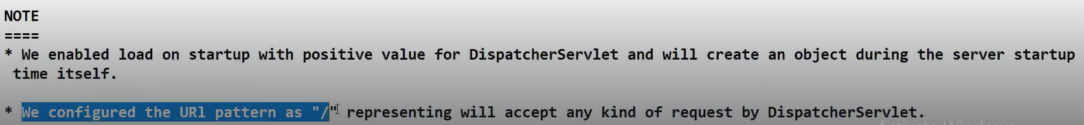

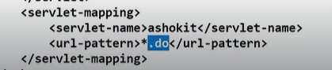

In this case, every request will be handled by Dispatcher servlet. Star means all. Here in this case, we are telling Dispatcher servlet to handle any request that ends with .do and please note that .do is not a predefined thing here.



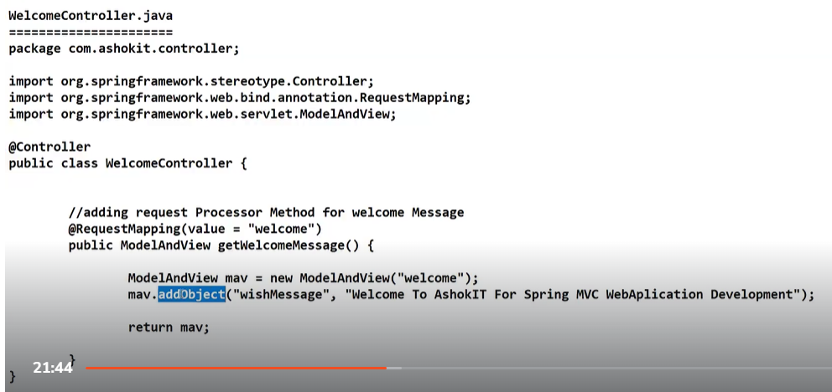

In the above screenshot , ModelAnd View = new ModelAndView(“welcome”) ---welcome is view-page name i.e JSP page name.We don’t need to give extension .jsp , it will be part of ViewResolver

Mav.addObject(“wishMesaage”,”Welcome to Ashokit…..”); == wishMessage is key of model data

Value of the key is “Welcome to AshokIT for ….”.

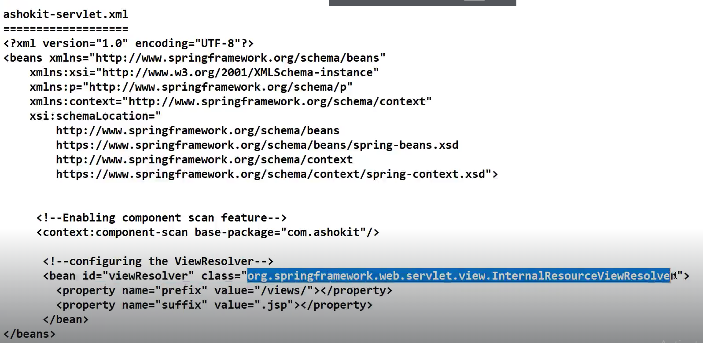

Beans are configured in spring.xml file.

ViewResolver is an Interface and it has multiple implementation classes and InternalResourceView resolver is an implementation class which is frequently used.

Prefix ---/views ==which means all view pages are avilable in views folder.views folder will be avilable in our project

Suffix ---.jsp == extension

 this is how view page location will be constructed by View Resolver.

**DispatcherServlet should be configured in web.xml file.**

**ViewResolver should be configred in spring configuration file**

**In Web application architecture, client will always be browser.Through browser only we can process the request**

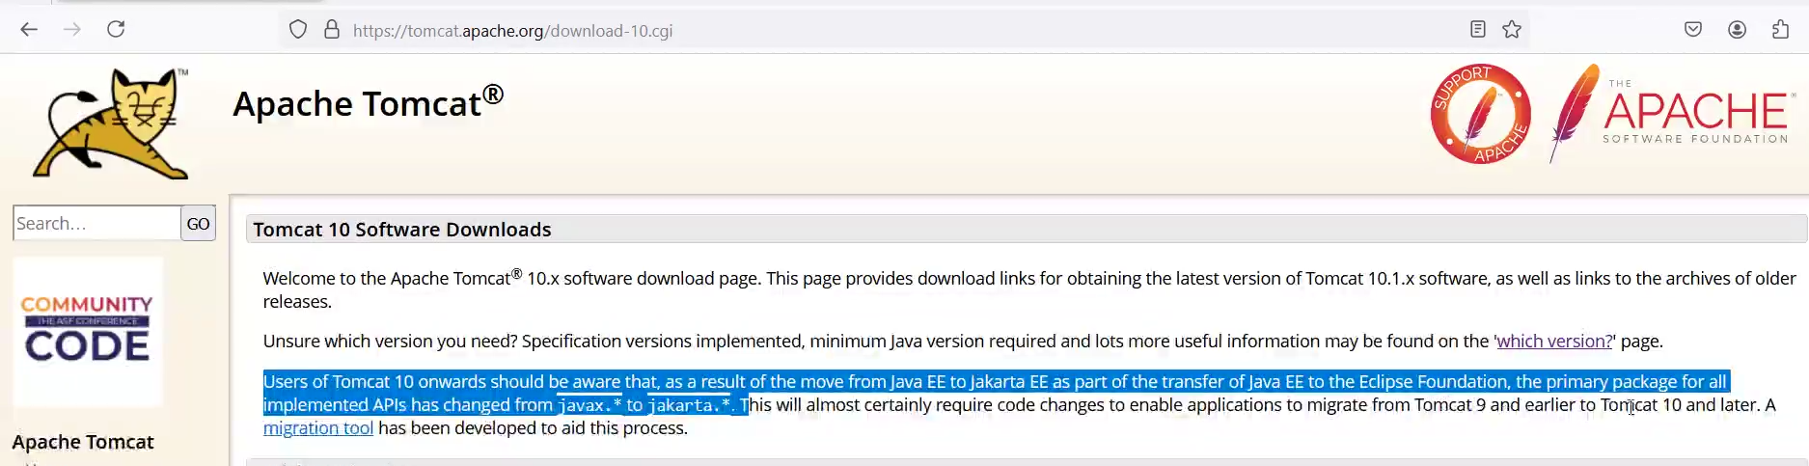

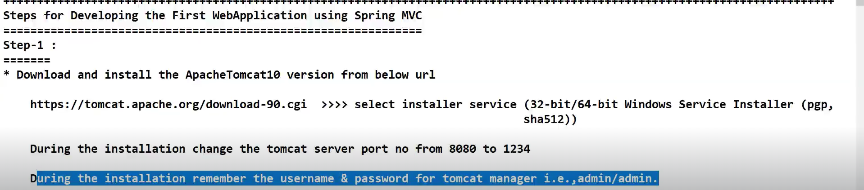

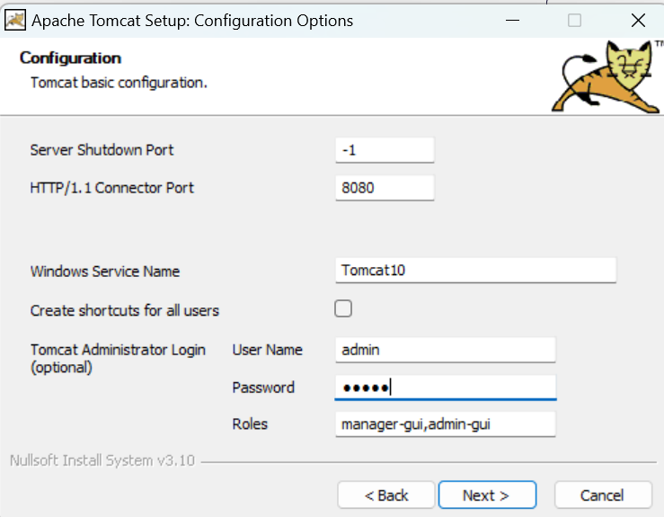

Password is also given as **‘admin’**

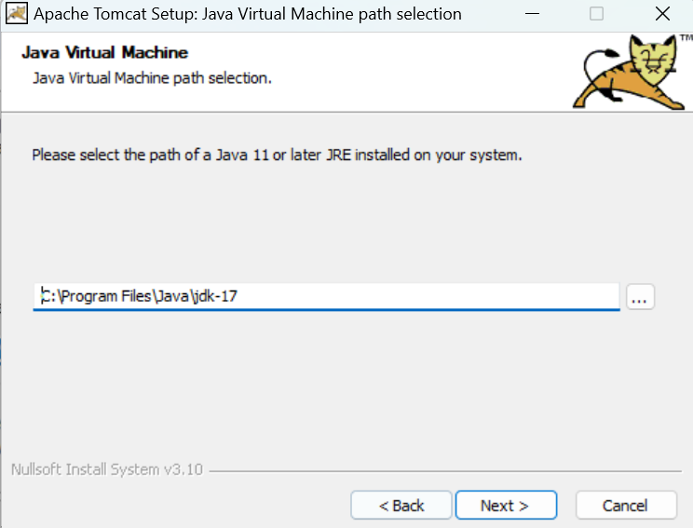

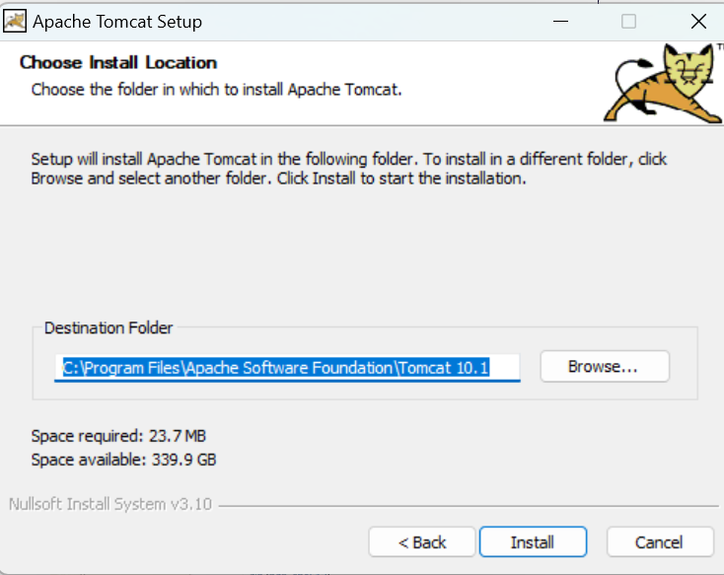

Go to

Go to C:\Program Files\Apache Software Foundation\Tomcat 10.1\conf

Change the port number from 8080 to 1345 in server.xml file

Sometimes developers forget port number and username password

**Port number we can get from sever.xml file .**

**Username and password information we can get from tomcat users.xml file.**

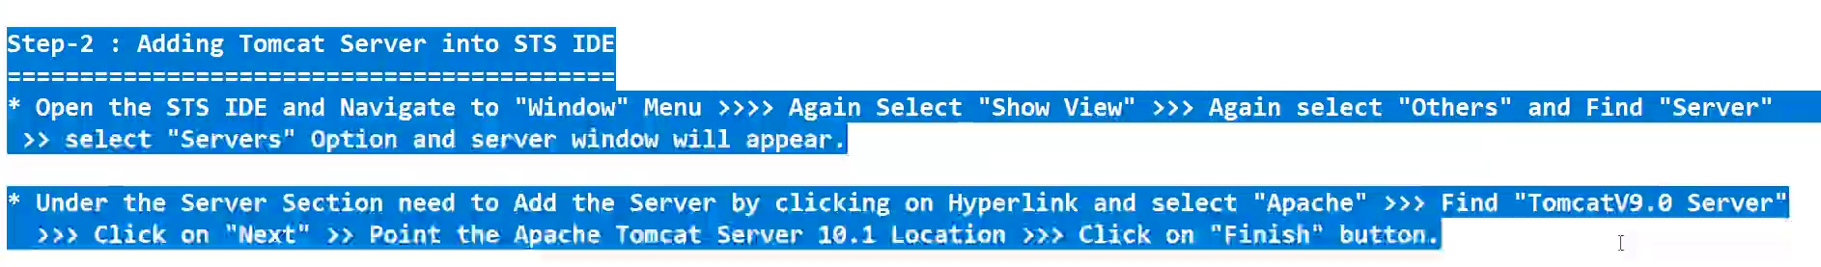

**SESSION-66**

**When we are creating a SpringBoot MVC, then we will create spring starter project.**

**When we are creating a Spring MVC, then we will create a Maven project**

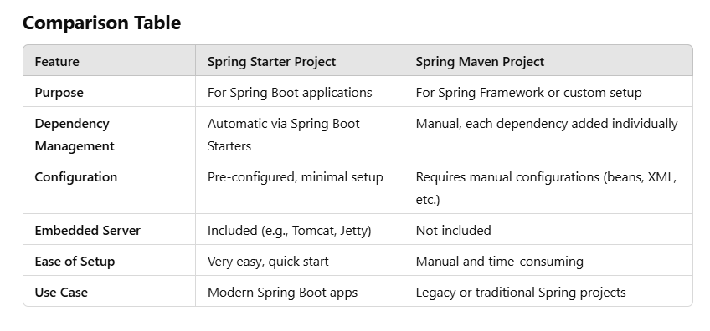

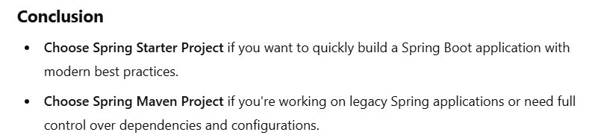

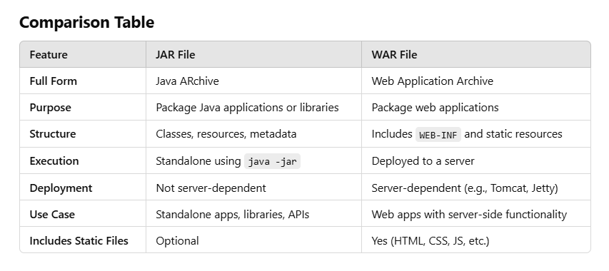

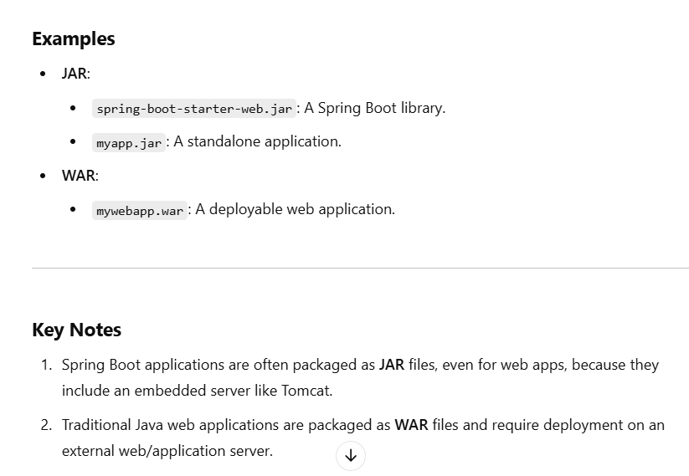

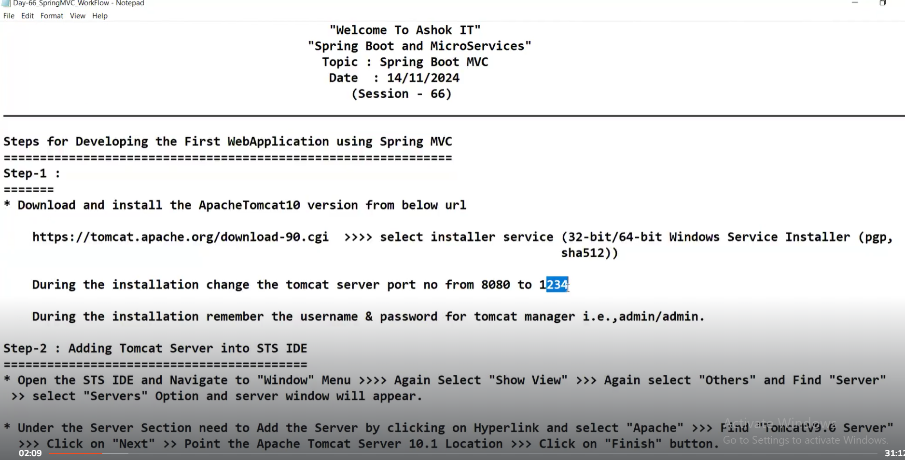

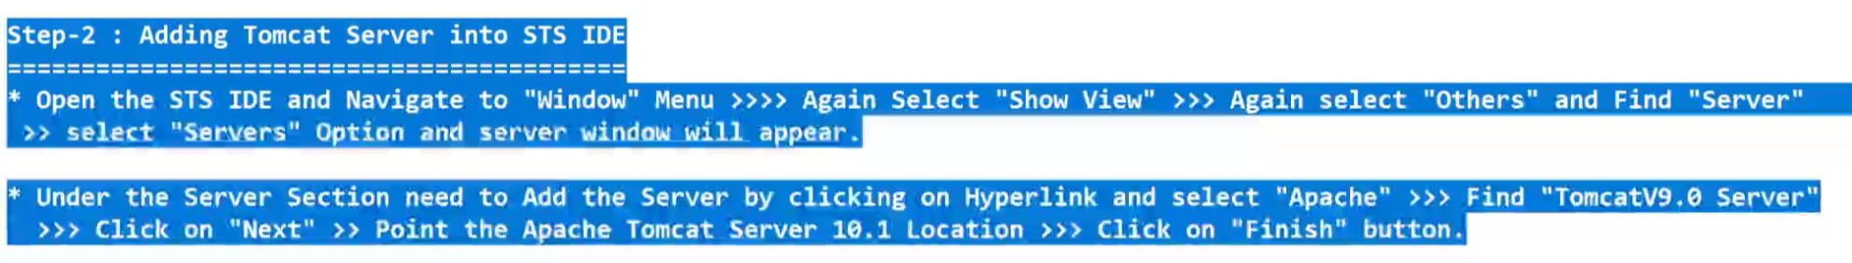

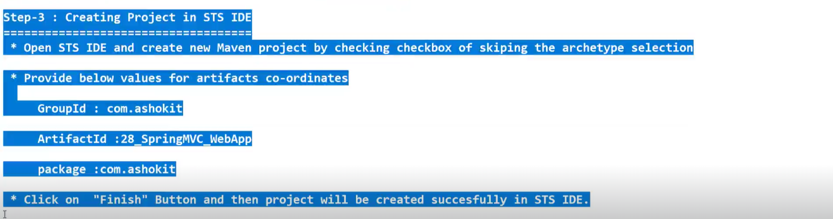

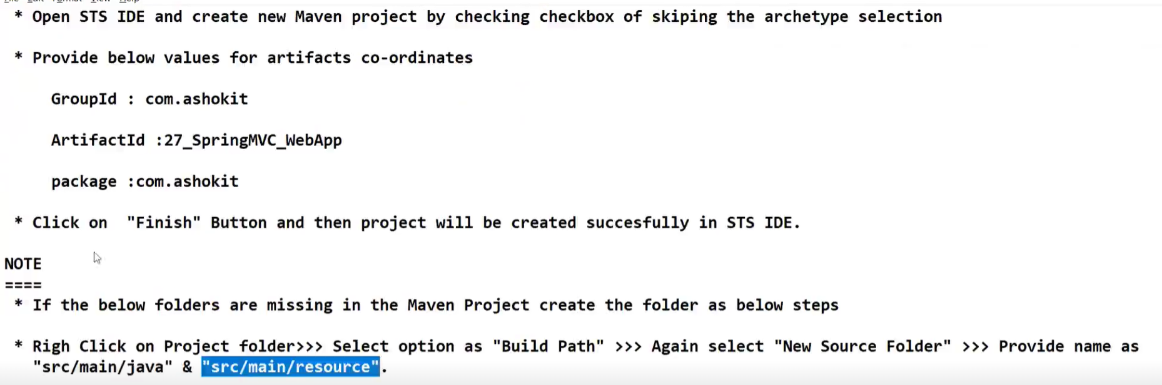

WEB-INF ===Web Information

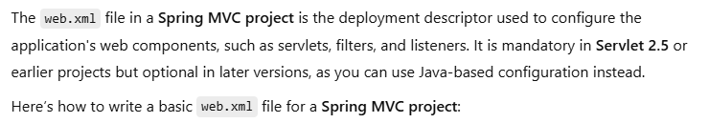

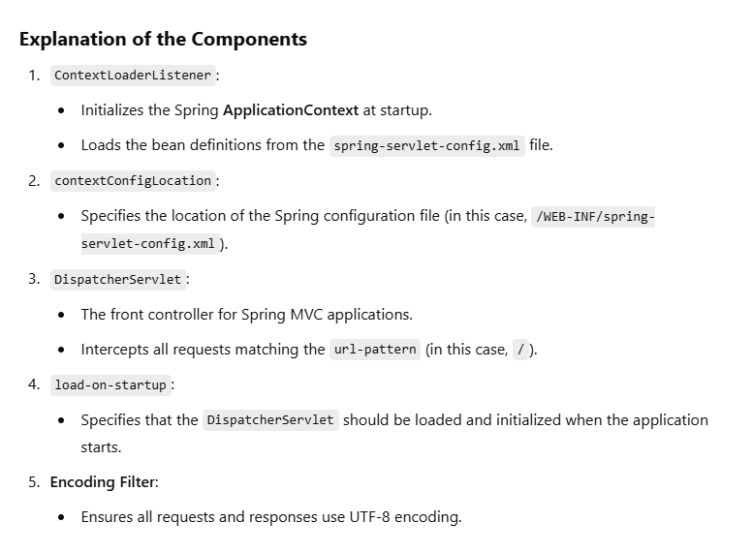

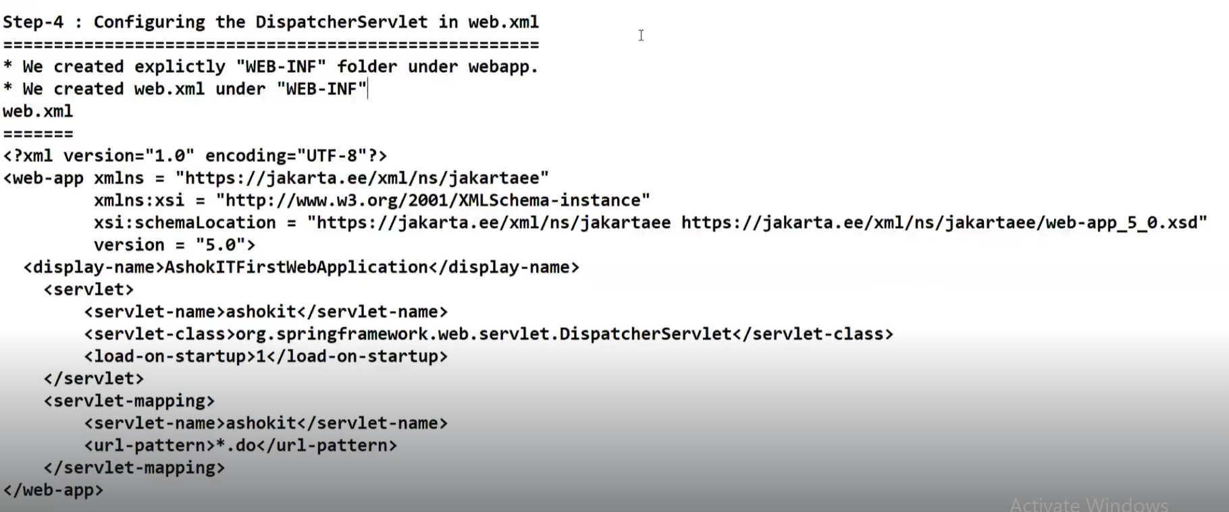

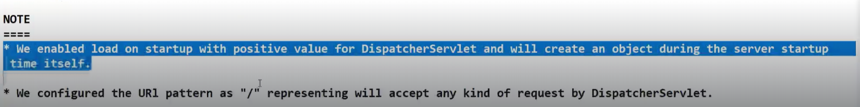

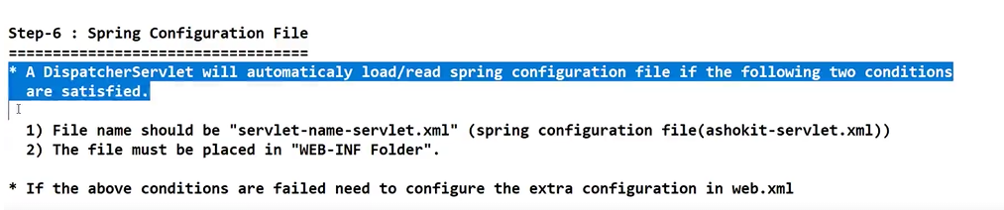

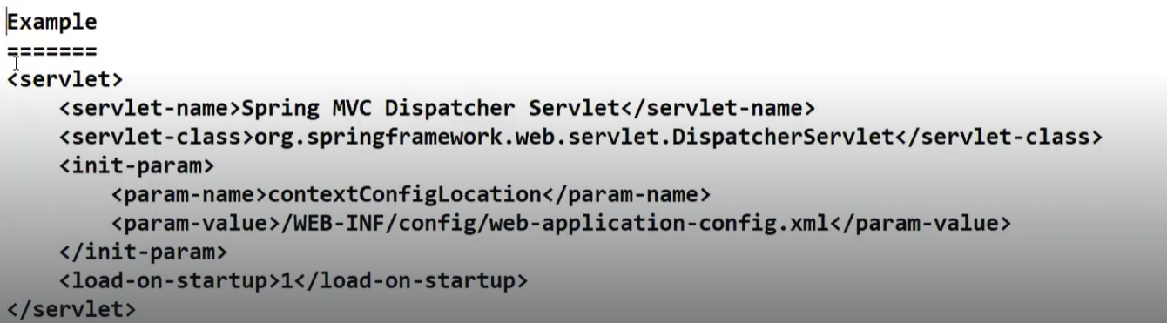

So basically for our web applications,web container inside Tomcat server will be taking care of creating Dispatcher servlet object.

Enabling <load-on-startup>1</load-on-startup> means we are informing web container to create an object of Dispatcher servelt at this location to be ready in our memory.

Dispatcher Servlet will take care of Handler mapping component, Helper controller,ModelAnd View,View resolvers etc..I.e MVC related infrastructure will be available to us.

Spring configuration file will be read by Dispatcher servlet.

**SESSION-67**

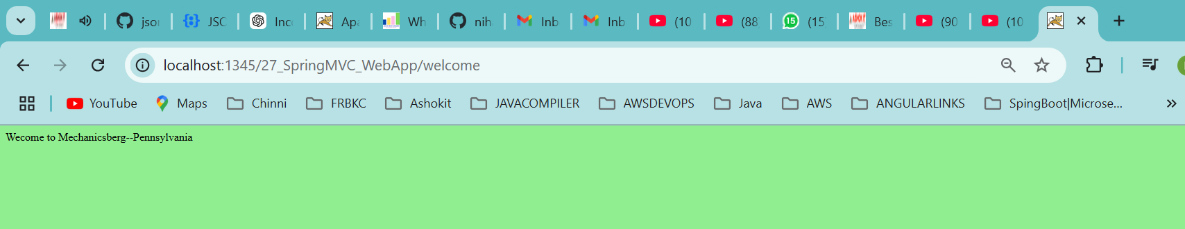

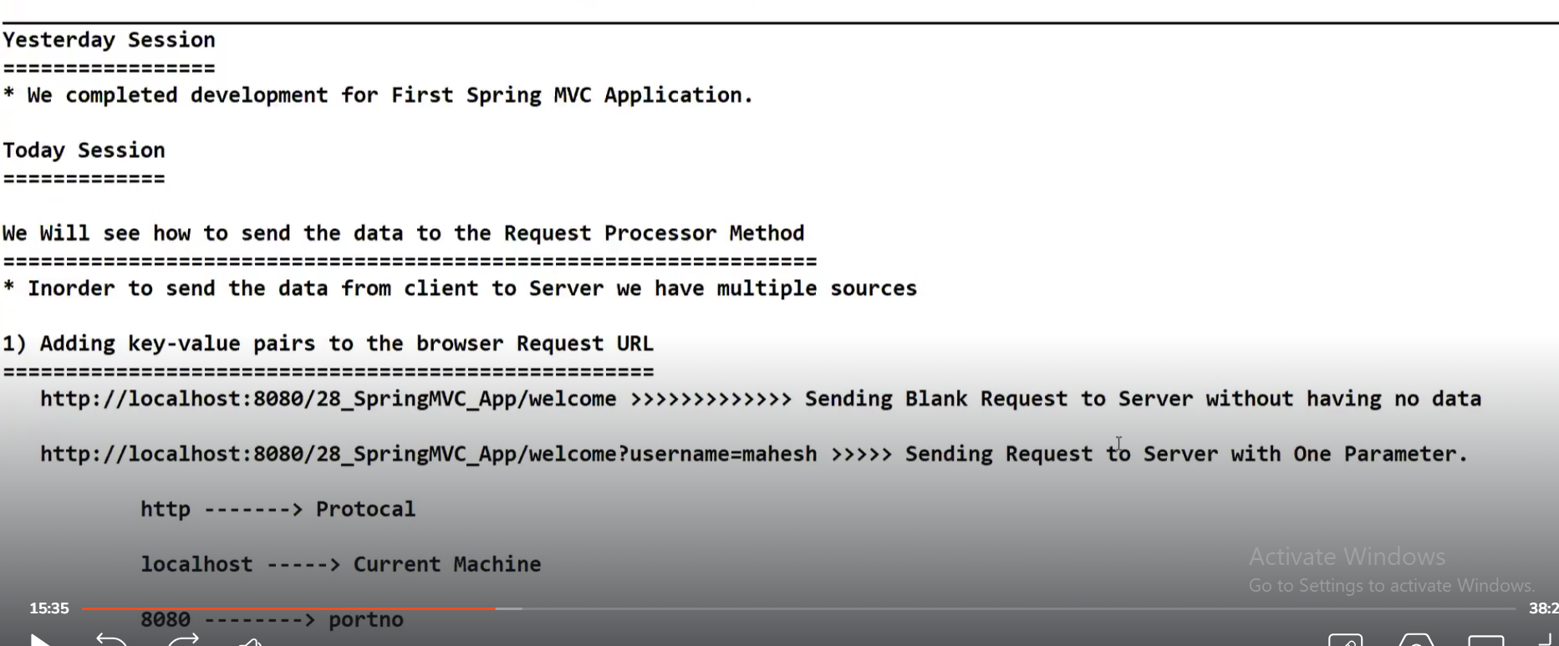

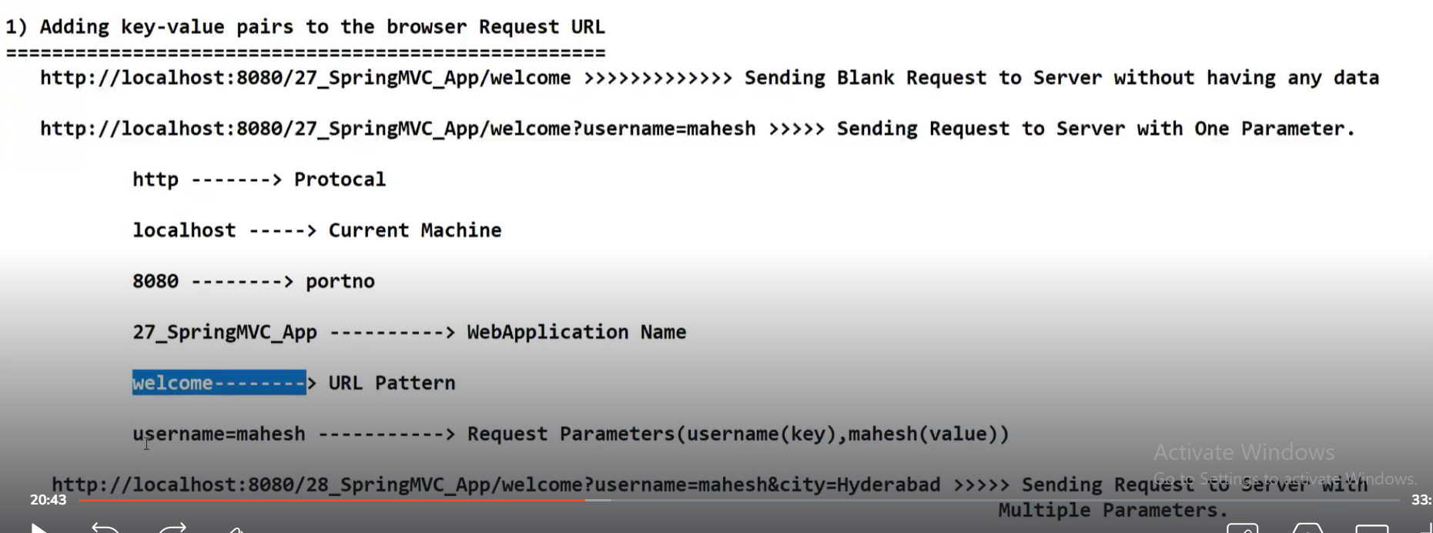

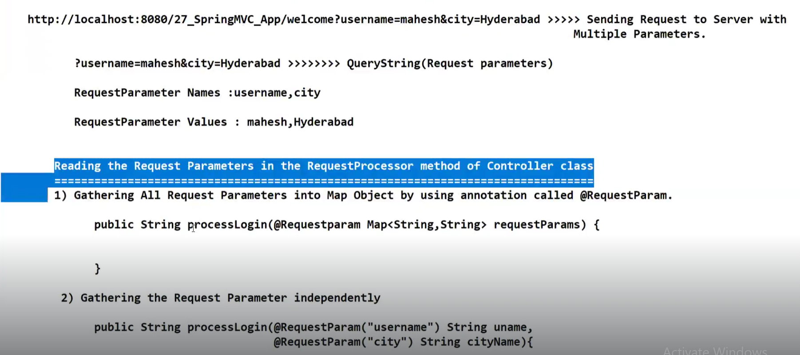

Map is the best data structure to store request params because request params are in Key-Value format.